Q4

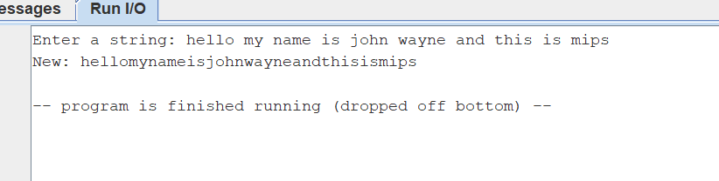

Q5

Test 1: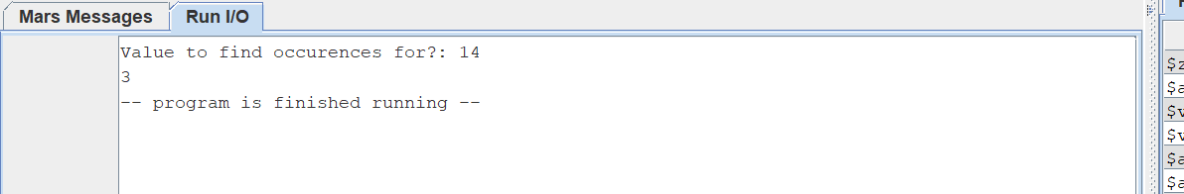

Test 2:

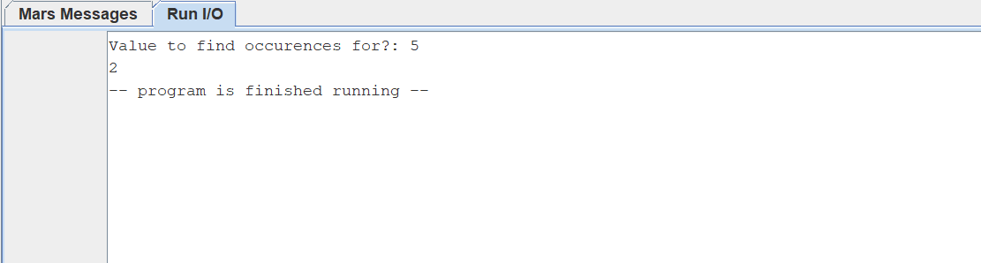

Test 3:

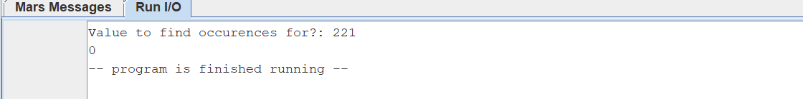

Q6

Test 1 n= 6

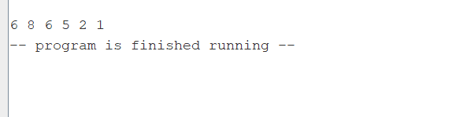

Test 2: n = 8

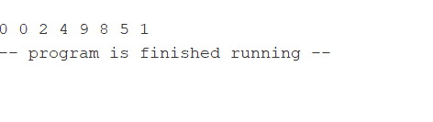

Test 3: n= 5

